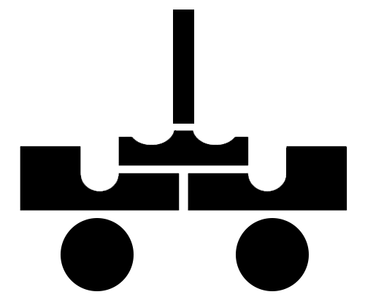

**Ball Manipulation Algorithms:**

* **Integrated with:**
  + **Navigation**
  + **Mapping**
  + **Odometry Correction**

**Necessary Hardware:**

* **2** EV3 Electric motors
* **3** Basic Rubber bands
* Custom launch arm / ball retrieval arm

**Ball Retrieval:**

* Mapping informs robot which two squares the ball dispenser straddles
* Robot uses light sensors to align itself in X/Y directions with ball dispenser
* Robot moves to known distance from dispenser and raises arm to specified angle (found in testing)
  + Robot beeps to inform instructors it is ready to retrieve ball
* **Design Benefits:**
  + No retrieval-specific hardware
  + Component reuse
  + Simple, effective method
    - Requires little additional software

**Ball Launching:**

* Mapping marks certain squares as positions the robot can successfully shoot & score from
  + Each square has a rank (1-4) indicating the priority the robot would ‘like’ to shoot from
    - Factors in ranking include distance from goal in both X and Y directions
    - Squares in center of field, closest to offense line are highest rank
* After retrieving a ball, robot navigates to highest priority shooting positions, if they contain obstacles, it continues to the next highest priority, etc.
  + Robot also checks *behind* its square for an obstacle
    - If obstacles is present, launching arm would strike obstacle and prevent accurate shooting
* Once ideal shooting position has been reached:
  + Robot aligns to X/Y coordinates to improve accuracy
  + Robot turns to face target
* To launch a ball:
  + Robot calculates distance from target
    - Uses preset ranges of distance to determine launch motors *acceleration, speed, range of motion*
  + Robot uses these values to control the motors and rotate launch arm quickly